# Lena php project document

<http://php.dev/Food/index.php>

Food main page header:

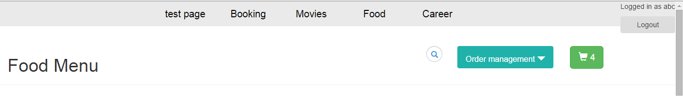

Food main page content:

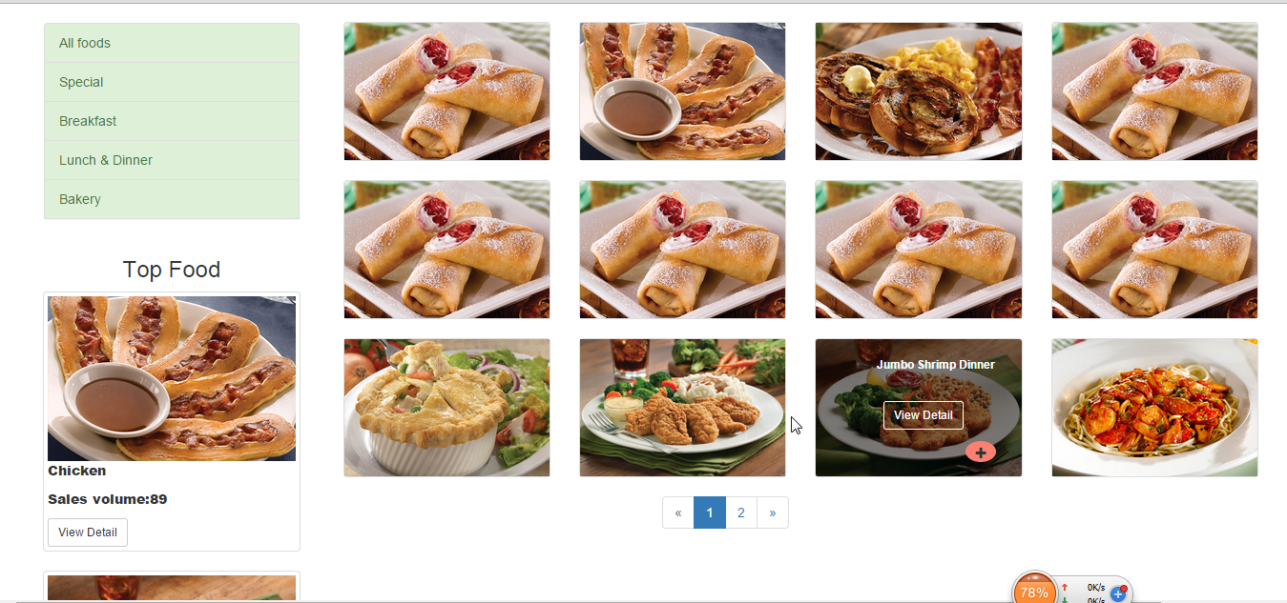

Find specific category’s food:

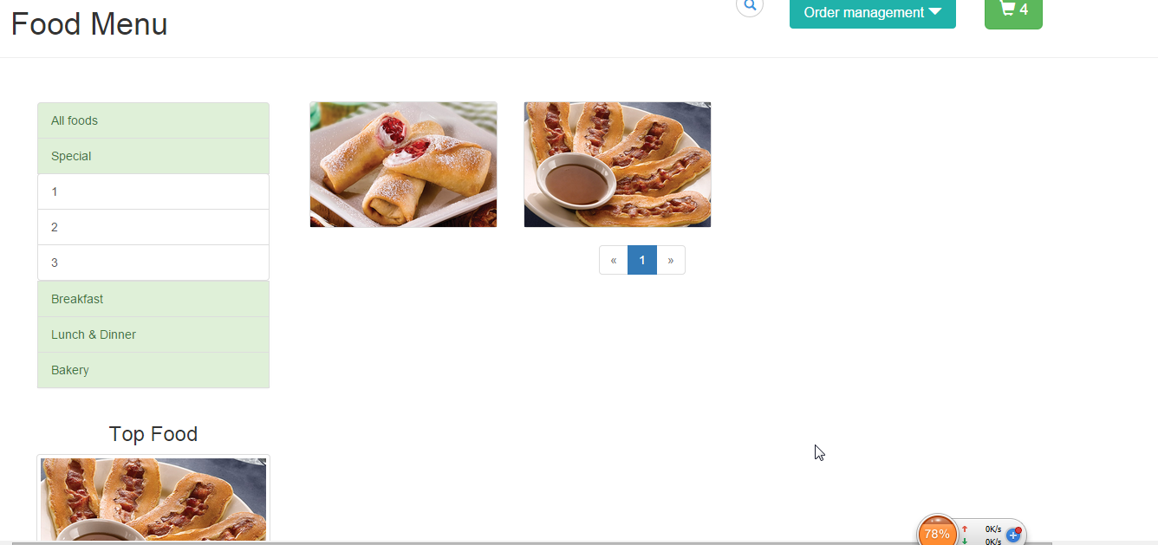

Search food function:

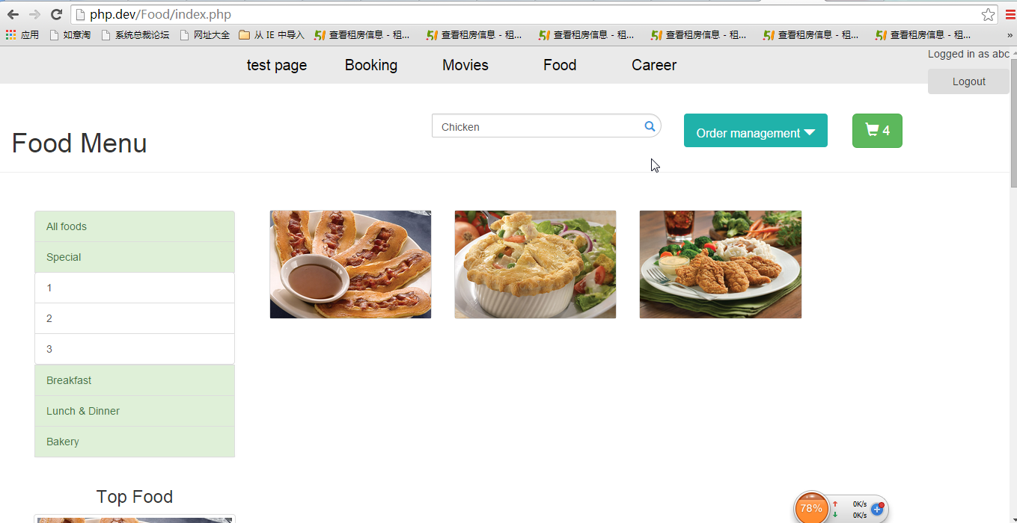

Find top food:

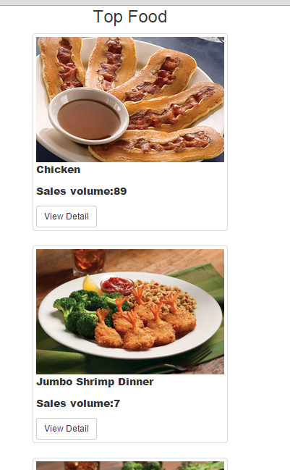

Url:http://php.dev/Food/FoodShoppingcartManagement/index.php

Food shopping cart page’s header:

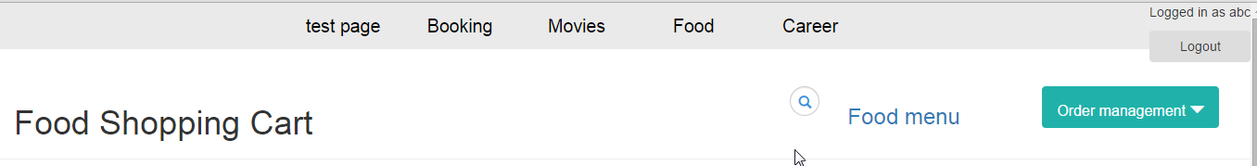

Food shopping cart page’s content:

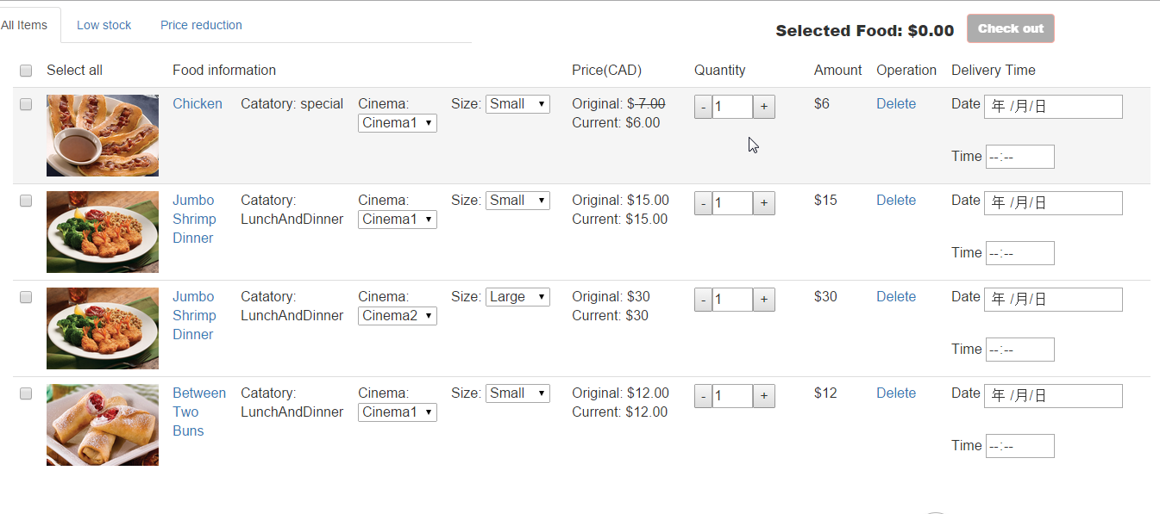

Food shopping cart page’s bottom part:

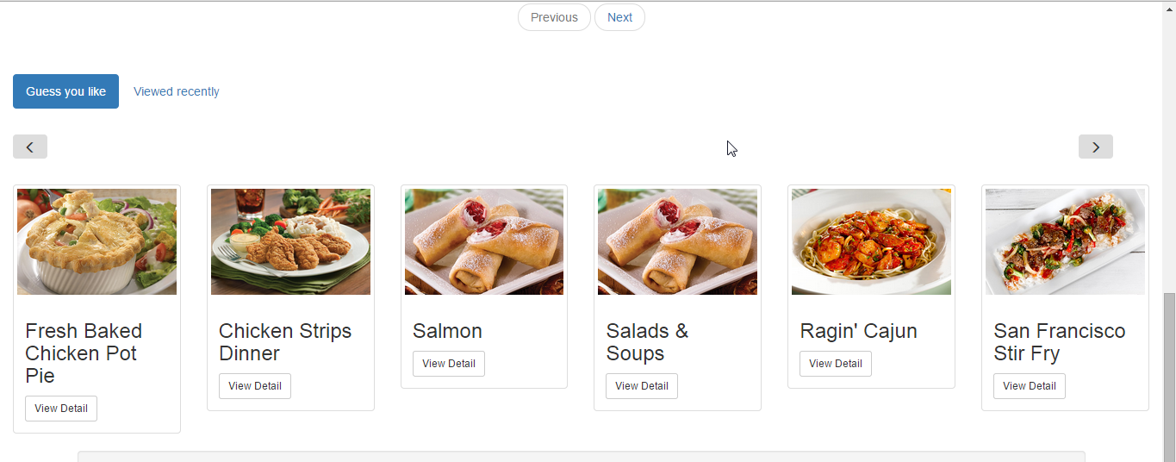

Get low stock food:

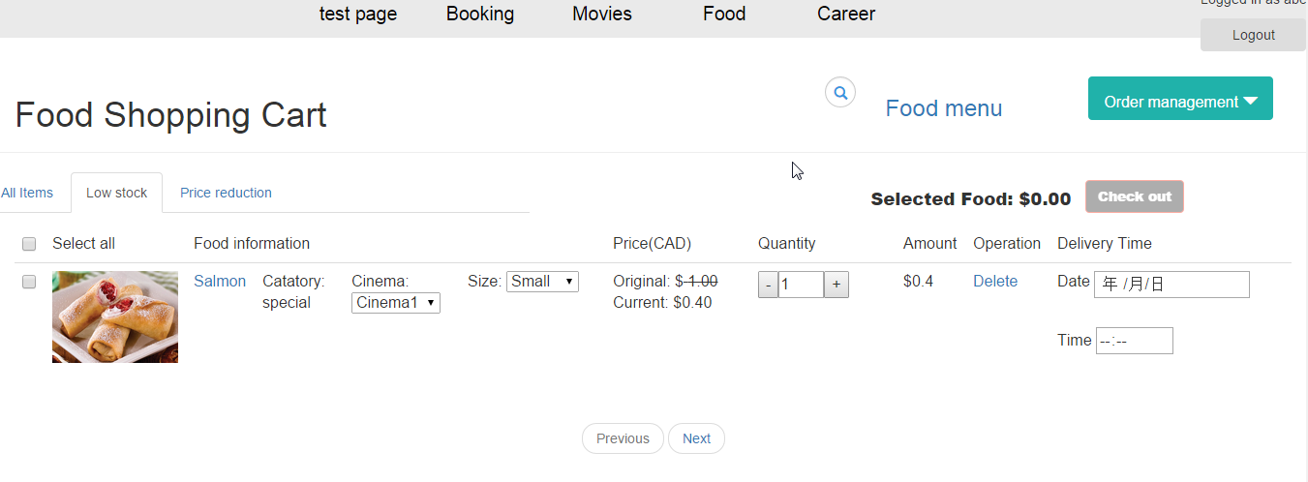

Get price reduction food(currently no this kind of food in database):

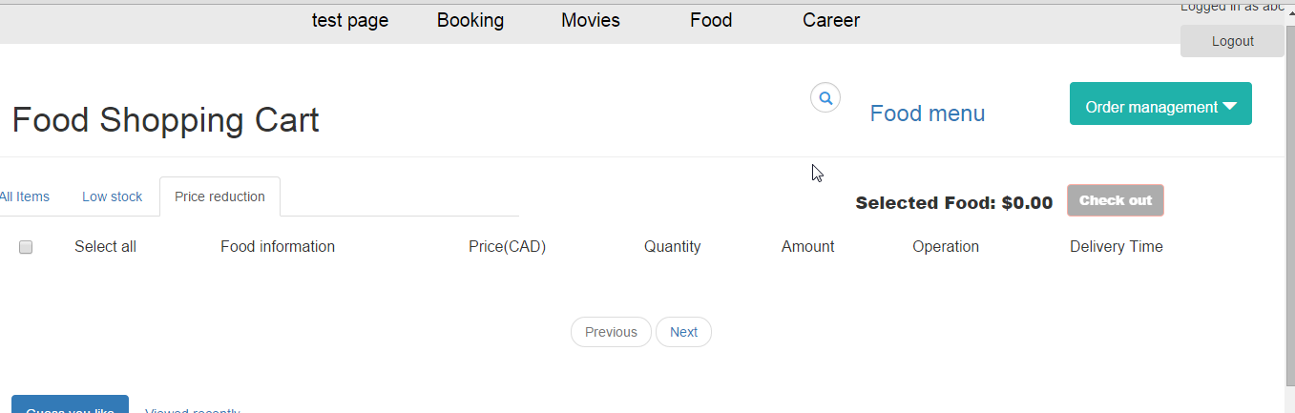

Guess you like function:

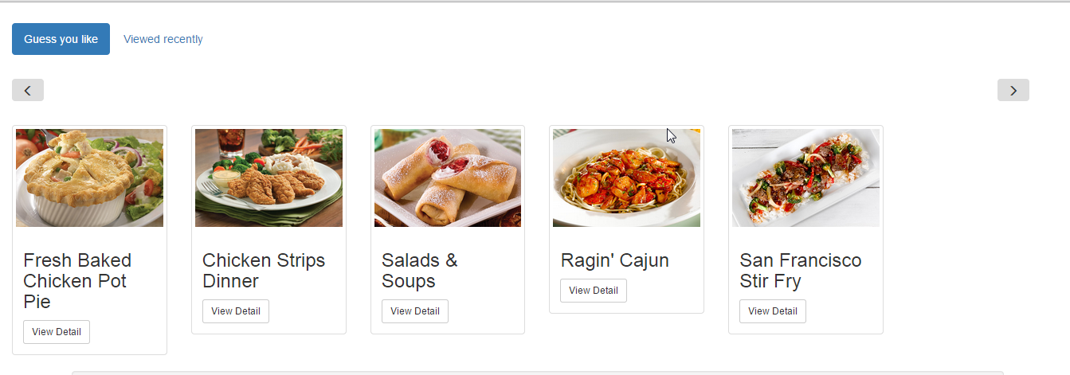

Viewed history function:

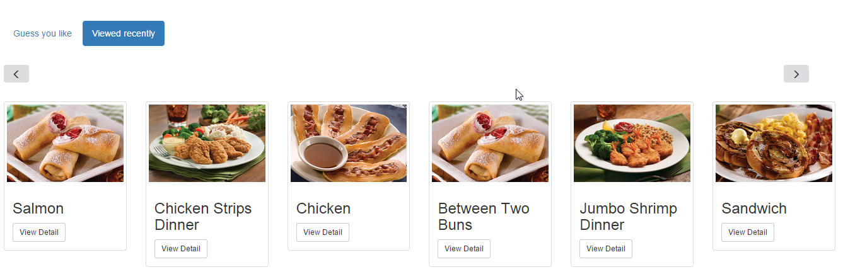

Calculate price function and checkout function:

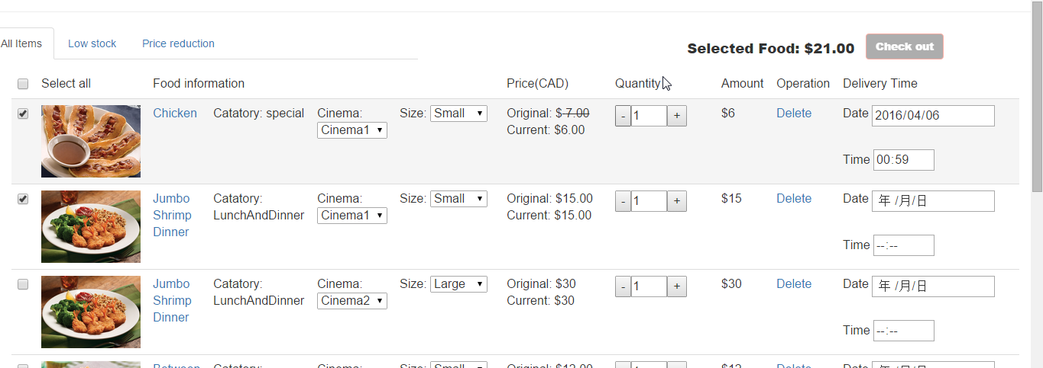

Url:http://php.dev/Food/order_management/index.php

Order management page’s head:

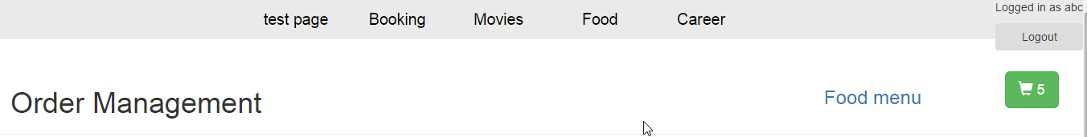

Order management page’s content:

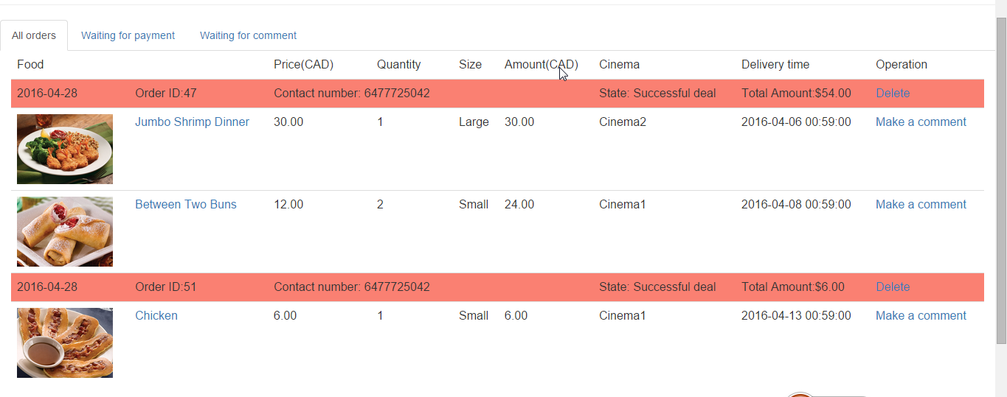

Find unpaid order function:

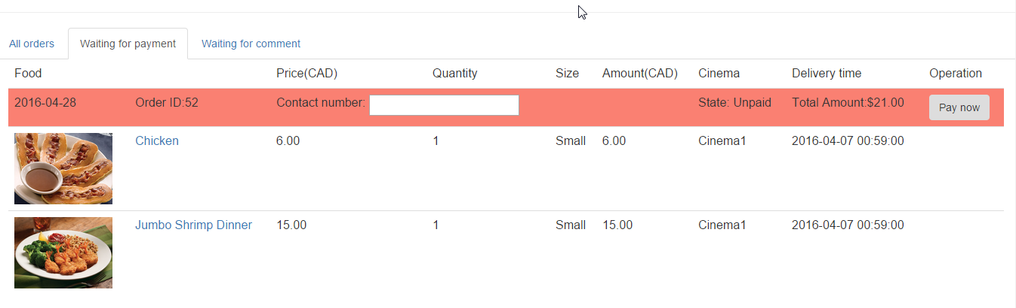

Find uncomment order function:

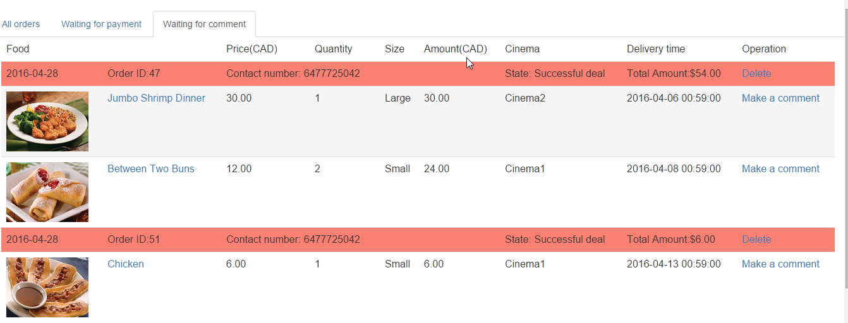

Url:http://php.dev/Food/Food%20Management/index.php?foodid=11&orderitemid=56

comment form page’s head

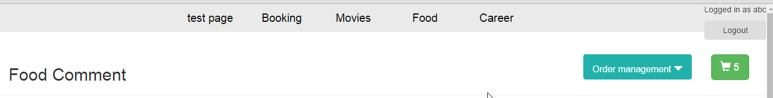

comment form page’s content

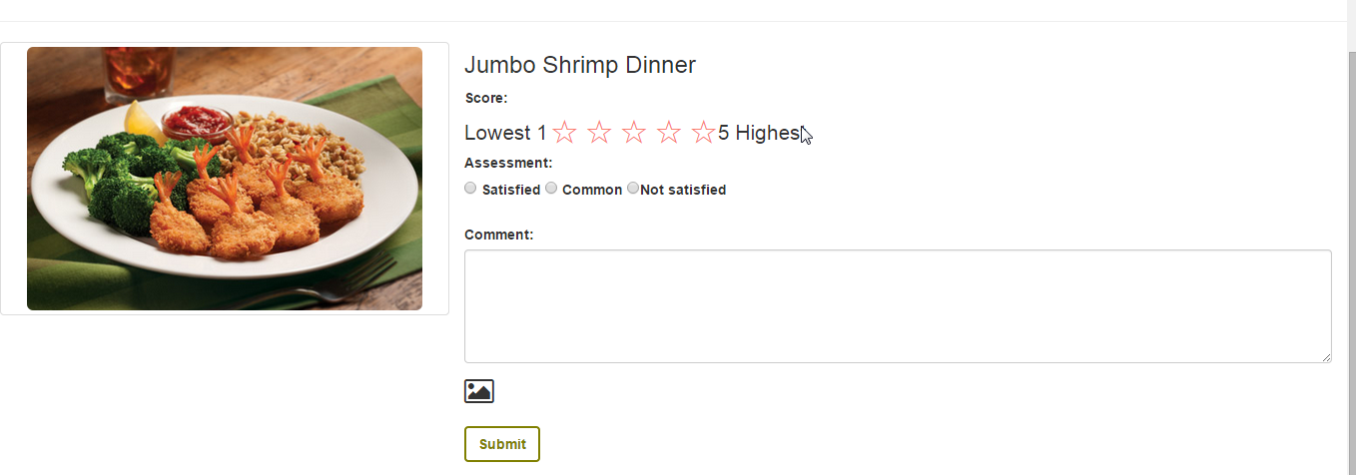

Comment function:

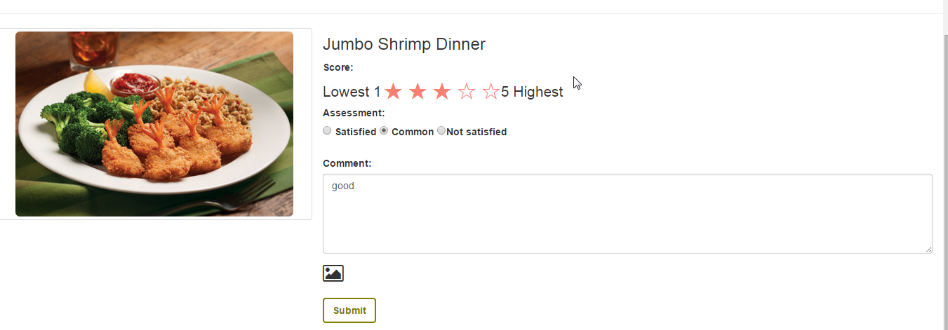

Calculate mark for every food and display comments in Food detail page:

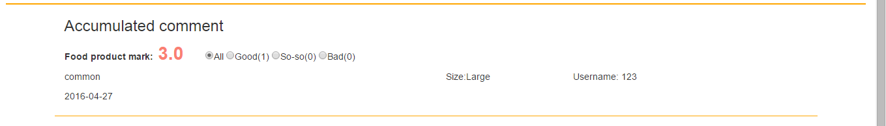

Url:http://php.dev/Food/Food%20Management/index.php?id=4

Food detail page’s head:

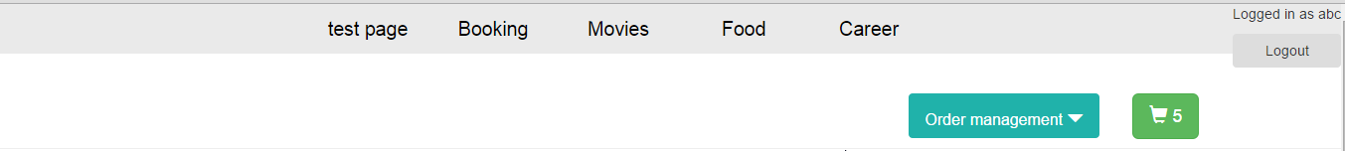

Food detail page’s content(Add to cart function):

